**Compare function**

Compare function is a function found in [sort array method](Data%20type/Reference/Array/Array%20methods.docx) responsible to ordering array elements **ascending** or **descending** or **Unicode** order (default ordering).

**Syntax:**

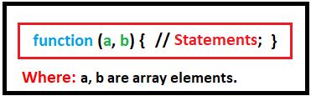

**How compare function works?**

On executing the array code, compare function passes on the elements of array from left to right and compare each two elements (a, b), and put the smaller or bigger one in the beginning of array and the second one after it (according to the ordering). Then it compares the second element with the third element in the array; it repeats this process until with all elements.

Compare function return 3 values (-1, 0, +1)

**If the return value is:**

* **negative value ordering will be** 🡺 **Ascending**
* **positive value ordering will be** 🡺 **Descending**
* **0 value ordering will be** 🡺 **Unicode ordering**

**Note:**

* -ve value returns when (a – b) or (a < b).
* +ve value returns when (b – a) or (a > b).
* 0 returns by default.

**Illustration:**

1. **For ascending ordering**.

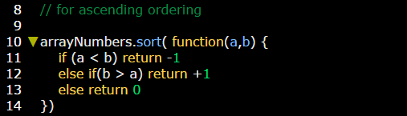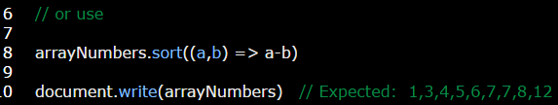

1. **For descending ordering.**

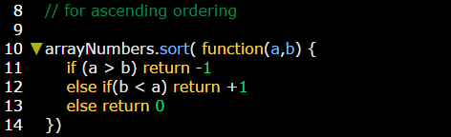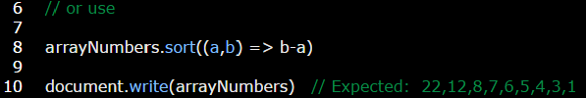

**Note:** you can use **reverse** array method to switch from descending to descending ordering and the verse.

**Example:**

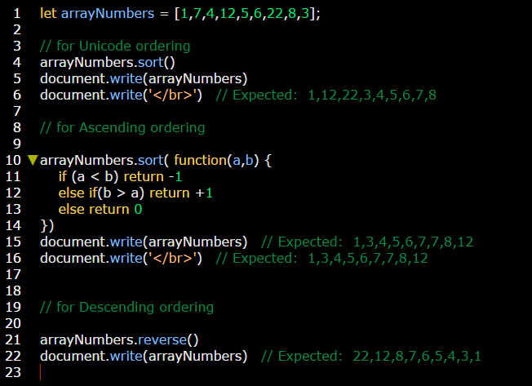

**Example:**

